Patch ID: e547a7e & ebd41fd

Patch Description:

e547a7e
db: fix notify data format for gateway ips
An upstream commit [1] changed how the gw_ips passed information thru the notify mechanism. It changed the data from a dict to a list of IP addresses but missed one line which is causing an exception in the neutron-dynamic-routing subproject in _handle_router_gateway_after_create.
[1] efe1c3087c1b47b67acc121b0f31e04c9fa0dd72
ebd41fd
fixup! db: fix notify data format for gateway ips

Call Flow

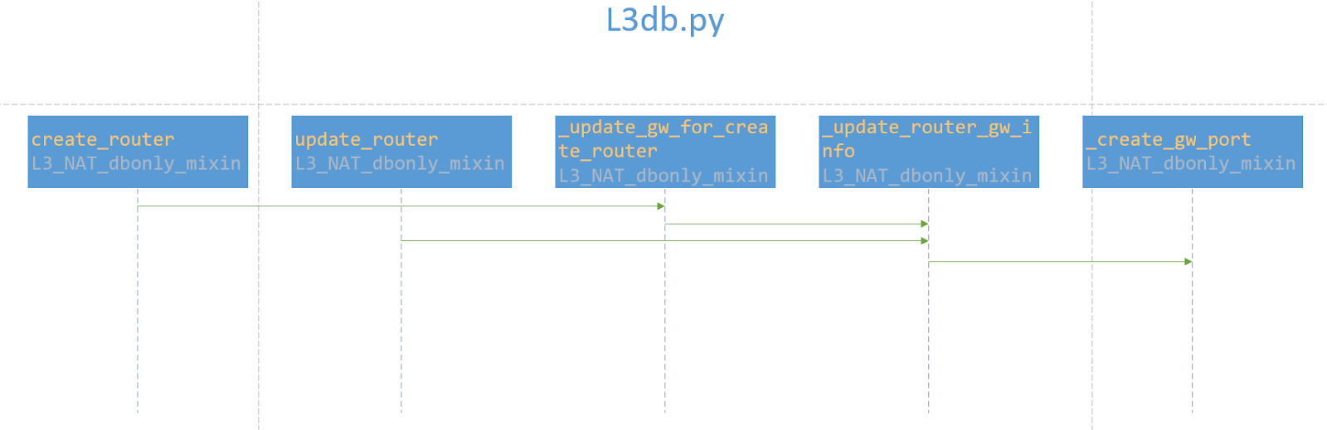

Analysis

Code for neutron upstream now:
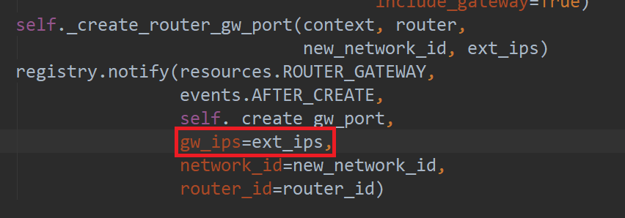

ext_ips: external_fixed_ips
Example:
ext_ips = [{"subnet_id": "966eff11-909d-4b6c-8d5f-4505e8a8c15f",
"ip_address": "192.168.1.200"},
{"subnet_id": "f2dee576-7535-40ee-a5ba-d5dae8e1f600",
"ip_address": "2001:db8::d"}]
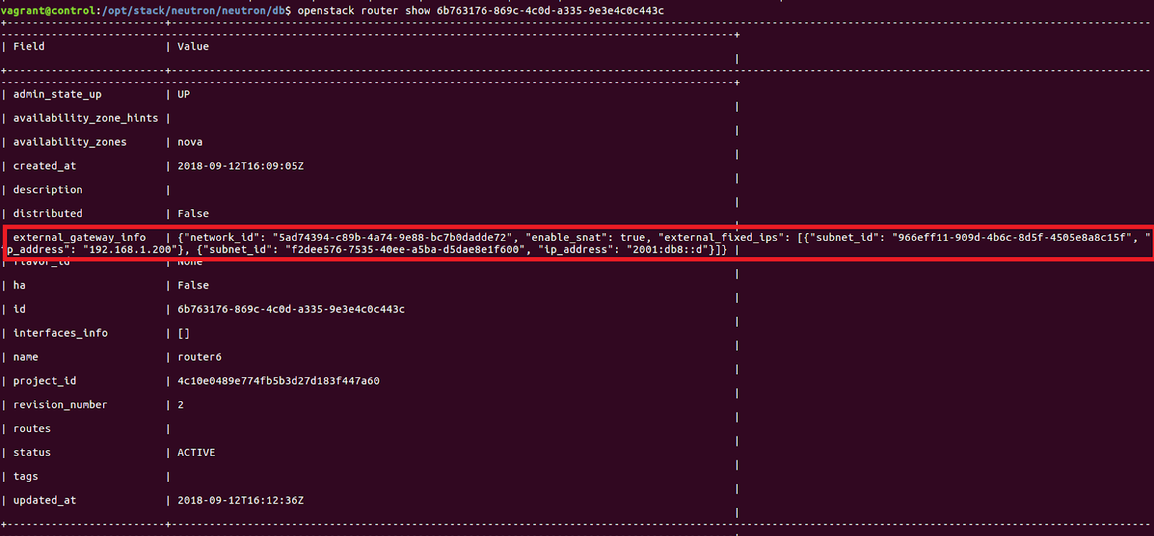

gw_ips: gateway_ips
gw_ips = [x['ip_address'] for x in router.gw_port.fixed_ips]
Example:
gw_ips = ['192.168.1.200', '2001:db8::d']

bgp_plugin in the project neutron-dynamic-routing will subscribe the topic and process the event.
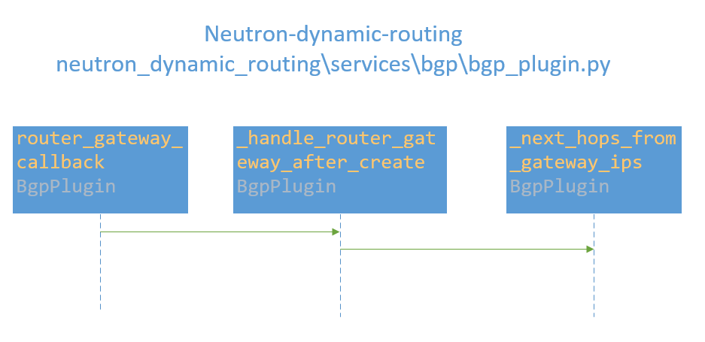
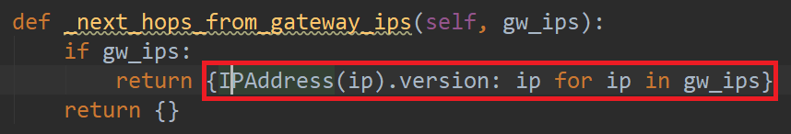

Function _next_hops_from_gateway_ips process the gw_ips finally. If the ext_ips are sent as gw_ips, then function _next_hops_from_gateway_ips can’t process it. “TypeError: unhashable type: 'dict'” will occur.
Example:
ext_ips = [{"subnet_id": "966eff11-909d-4b6c-8d5f-4505e8a8c15f",
"ip_address": "192.168.1.200"},
{"subnet_id": "f2dee576-7535-40ee-a5ba-d5dae8e1f600",
"ip_address": "2001:db8::d"}]
gw_ips = ['192.168.1.200', '2001:db8::d']

The code should be fixed in this way:
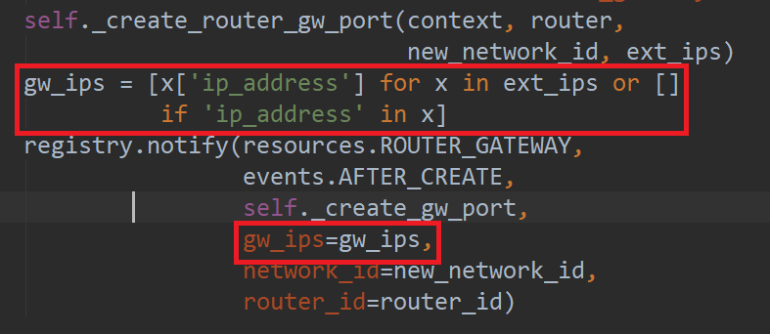

Summary
- It’s a bug for neutron upstream and should be fixed.

